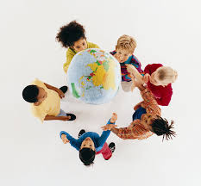
St Margaret’s CE VA Primary School Geography Units
Nursery
- The weather
- Walks around school
- Seasons

Reception
- A Place Called Home (Autumn)
- Gateway to Geography (Spring)
- Out and About (Spring)
- The United Kingdom (Summer)

Year 1
- What’s the geography of where I live like? (Autumn 1 )
- Why don’t penguins need to fly? (Spring 1)
- Why do we love being beside the seaside so much? (Summer 1)

Year 2
- How does the weather affect our lives? (Autumn 1)
- Why does it matter where our food comes from? (Spring 1)
- How does the geography of Africa compare with where I live? (Summer 1)
*Uganda used in Yr2 rather than Kampong Ayer to tie in with school links

Year 3
- How and why is my local environment changing? (Autumn 2)
- Beyond the Magic Kingdom: What is the Sunshine State really like?
(Spring 2)
- Why do so many people live in megacities? (Summer 2)

Year 4
- Why do the biggest earthquakes not always cause the most damage? (Autumn 2)
- How can we live more sustainably? (Spring 2)
- Why are jungles so wet and deserts so dry? (Summer 2)

Year 5
- What is a River? (Autumn 2)
- Who are Britain’s National Parks for? (Spring 2)
- How is climate change affecting the world? (Summer 2)

Year 6
- Why are mountains so important? (Autumn 1)
- How do volcanoes affect the lives of the people on Hiemaey? (Spring 1)
- Why is Fairtrade Fair? (Summer 1)

